Automation and Control of Hydroponic Systems

Marshall Amey, Kathya Alfaro, Isaac Olson, Madeline Wrzesinski  
San Antonio College

Summer 2017

**Table of Contents**

**Table of Contents………..………………………………………………………………………………...2**

**Abstract ……………………………………………………………………………………….…………...3**

**Introduction .……………………………………………………………………………….……………...4**

**Materials and Methods……………………………………………………………………………………6**

Prototype System Design ………………….……………………………………………………………….7

Electrical Hardware Design ………………………..…………………………………….………………...7

Software Program Design…………………………………….…………………………….......................10

sendSensorCommand( ); ……………………………………….………………………...............11

readData( ); …………………………………...……………..…………………………...............11

printToInternet( ); ………………………………………...……………………………………...11

monitorSystem( ); ……...………………………………………………..……………………….11

printToLCD( ); ……………………………………...…………………..………………………..12

System Testing …………………….……………………………………………………………………...12

**Results and Discussion…………………………………………………………………………………...13**

pH ……………………..……………………………………………………………………..……………13

Conductivity ………….………………………………….………………………………………………..13

Water Temperature ………………….…………………….……………………………………………...14

Air Temperature ………………………………..………..………………………………………………..14

Humidity …………………………………………………...……………………………………………..15

Dissolved Oxygen ………………………………...………………….…………………………………...15

Carbon Dioxide ……………………………………..……………………………..……………………...16

Photosynthetically Active Radiation ………………………………………………………….…………..16

**Conclusions …………………………………………………………………………………..…………..16**

Cost Analysis …………………………………………………………………………………..................16

Challenges………………………………………………………………………..………………………..18 Conductivity Issues ……………………………………….……………………………………...18

Wifi Connectivity ……………………………..……………..…………………………………...19

Power Issues ………………………………………...…………………………………................20

Menu Functionality ……...…………………………………………..…………………………...21

Future Suggestions ………………………………………………………………………………………..21

**Acknowledgements …………………………………………………………………..………..................24**

**References ………………………………………………………………………………………………..25**

**Appendix A – Tables ………………………………………………………………..…………………...29**

**Appendix B – Figures ……………………………………………………………………….…………..30**

**Appendix C – Materials & Budget …………………………………………………….…….................39**

**Abstract**

The goal of this research project was to design, build, and test a low-cost prototype system to automate and control critical variables of the environment in a containerized hydroponic garden. Optimizing the production of hydroponic shipping container systems for cost-efficiency and ease of operation could revitalize the health of low-income and urban communities located in food deserts. With these systems, communities would have close access to healthier, more natural food options year-round. By creating simple technology that optimizes plant yield at the lowest cost, more research can be conducted to study the potential of hydroponics to improve environmental sustainability and end hunger, locally and abroad. This project used Arduino microcontroller technology and an array of sensors to measure pH, conductivity, and oxygen levels of the nutrient solution; temperature, humidity and CO2 levels in the air; and the photosynthetically active radiation of the lights. The data compiled by the system is uploaded to the Internet, where it can be viewed remotely. pH and conductivity levels are monitored and regulated continuously without human intervention. The completed system is able to control the environment at a substantially lower cost than most commercially available equipment on the market.

Keywords: hydroponics, gardening, automation, agriculture.

**Introduction**

The human population is growing rapidly and will reach approximately 9 billion in the next 30 years (Touliatos, 2016). In order to meet the growing demand for food, there will need to be a 70% increase in agricultural production (Corvalan et al. 2005; Tilman et al. 2011). Because the earth’s resources are already strained, it is important to find alternative methods of food production that do not involve further land degradation and loss of biodiversity. In collaboration with the Texas State University ReEnergize Renewable Energy Research & Education Partnership, San Antonio College students have been designing and constructing a hydroponic system inside a shipping container. The goal is to develop an improved and cost-efficient containerized hydroponic system that can test horizontal and vertical hydroponic tubing systems and experiment with low-energy grow light systems that draw upon solar energy (ReEnergize, n.d.).

Growing leafy greens and herbs inside shipping containers has become a new and exciting niche in the agricultural industry. Already, companies like Growtainer, Freight Farms, and Vertical Harvest Hydroponics have been making important strides in advancing new agro-technology. Last November, Kimbal Musk, brother of Elon Musk, launched an urban farming program in Brooklyn called Square Roots (Garfield and Jacobs, 2017). This program intends to help young entrepreneurs develop vertical farming startups using hydroponic systems in shipping containers. The majority of these companies use a vertical growing system to maximize their plant yield and each shipping container can produce between 25,000 to 50,000 heads of leafy greens per year (Barth, 2015; Garfield, 2017; MacFarland, 2015). They have also championed the use of LEDs as a light source, and all elements within their container systems can be measured and changed remotely. Some systems even come with smartphone apps that meet this purpose.

In trying to determine an estimated cost, a variety of information was considered. Nicholas Heredia (2014) was able to construct a small, hydroponic garden of lettuce for under $300 as a student at California Polytechnic State University. This small system was only able to grow 20 plants at a time. On the other end of the spectrum, purchasing a fully operational shipping container from Freight Farms would cost $76,000 plus $13,000 per year in operational costs (MacFarland, 2015). Although the cost is significantly higher, one farmer can grow up to 4500 plants per container at a time and the technology to manage the system has already been created and installed. This project was able to produce a similar type of system as these pioneering companies by using an Arduino microcontroller and an array of sensors to measure pH, conductivity, and oxygen levels of the nutrient solution; temperature, humidity and CO2 levels in the air; and the photosynthetically active radiation of the lights. The data compiled by the system is uploaded to the Internet, where it can be viewed remotely. The popularity of Arduino’s open source hardware has allowed many designers, students, and makers to easily create the same kinds of technology as the new agro-tech companies previously mentioned. Arduino is a flexible, programmable hardware platform with a fairly standard onboard microcontroller that can interact with the world around it by using its programmable inputs and outputs (Arduino, 2017). The core language used in the Arduino development environment is the C programming language.

Current and past members of the ReEnergize project have performed research and experiments on a motorized vehicle to be placed inside the shipping container in order to take sensor readings (Ward, 2016). They built and tested two different, robotic vehicles that could be programmed to move via line sensor technology. A hoisting mechanism on top of the vehicle was meant to allow sensors to reach different vertical heights where additional readings could be taken. In light of our goal to produce plants simply and cost efficiently, it seems more appropriate to place multiple, stationary sensors inside the container that will take readings at different parts of the container than to build a movable robot. The robot may require future owners of the system to have a higher degree of technical knowledge in the event of a malfunction.

**Materials and Methods**

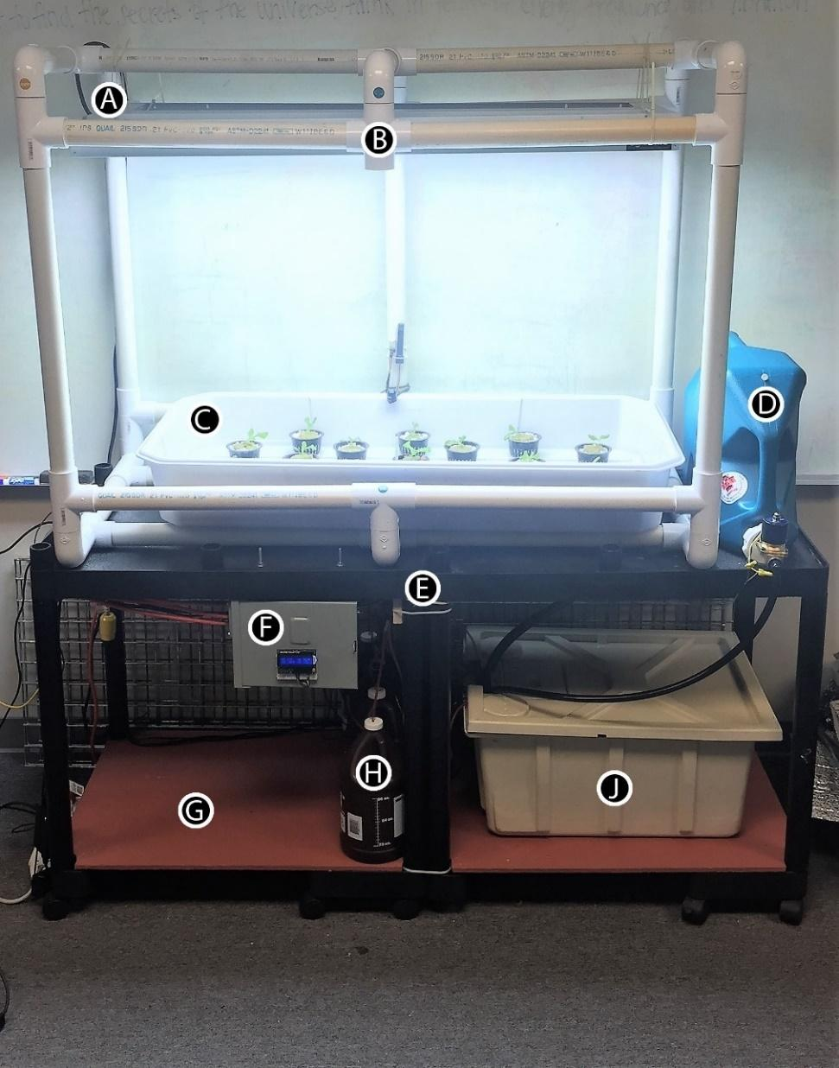

**Figure 1.** Hydroponic System Prototype

**Prototype System Design**

Referring to **Figure 1**, a PVC frame (B) was constructed to hold an Active Aqua Premium High-Rise Flood Table (C) and an Agrobrite T5 energy saving grow light (A). This structure sits on top of two conjoined rolling carts (E). A piece of ½” plywood (G) was measured, painted and placed on the base of the carts to provide an even surface to store equipment. An additional 7-gallon reservoir (D) was added to the side of the PVC structure to replace water lost to evaporation and to dilute the nutrient solution when necessary. The bottom of the rolling cart houses a Botanicare 20-gallon reservoir (J) and four 1-gallon jugs (H) filled with different solutions. The solutions are dispensed into the reservoir using peristaltic pumps mounted to the underside of the rolling carts (See Appendix B - Figure 4B). The electrical box (F) is also mounted to the underside at the front of the system. Inside the bottom reservoir, a Total Pond 300 GPH submersible water pump sends the nutrient solution to the flood table through ½” tubing. The solution returns the reservoir through ¾” tubing. This was done to prevent overflow in the flood table. Holes were drilled in the flood table to install the appropriate Active Aqua drain fittings. Two ¼”tubes were connected to an Active Aqua air pump and placed inside the bottom reservoir. One tube blows air to mix the solution. The second tube is connected to an airstone to increase the oxygen content of the nutrient solution, when necessary.

**Electrical Hardware Design**

The Arduino Mega 2560 was chosen to control all sensors and motors necessary to monitor and regulate the hydroponic system. This device is a microcontroller board based on the ATmega2560 chip. It has 54 digital input/output pins, 16 analog inputs, 4 hardware serial ports, a 16 MHz crystal oscillator, a USB connection, a power jack, an ICSP header, and a reset button (Arduino, 2017). The completed system currently uses 21 digital pins and 6 analog pins to connect all the necessary components to the Arduino. This leaves plenty of room for scaling the system in the future. In order to get all the required information from the environment, the following sensors were used:

* Atlas Scientific PT-1000 Temperature Probe
* Atlas Scientific Conductivity Sensor
* Atlas Scientific pH Sensor
* Atlas Scientific Dissolved Oxygen Sensor
* Gravity: UART Infrared CO2 Sensor
* SMAKN® DHT22 / AM2302 Digital Temperature and Humidity sensor
* Vernier PAR Sensor

The Gravity CO2 sensor and all Atlas Scientific probes require serial communication and must be connected to TX and RX pins on the Arduino. Since there are only 3 available hardware serial ports on the Arduino Mega (Arduino, 2017), 2 additional ports were created using the software serial library found on the Github platform (GitHub, 2016). Table 1A lists the connections between the Arduino and the sensors (See Appendix A). Each variable to be measured was given a 2-letter code for easy reference. The pH, dissolved oxygen, and conductivity sensors are very sensitive measuring devices and need to be electrically isolated with a voltage isolator in order to prevent electrical noise from interfering with their readings (Atlas scientific, 2017). The Vernier PAR sensor was connected to the analog port A0 using a Vernier protoboard adapter (Vernier Software & Technology, 2017).

The lights and all motors were connected via a JBtek 8-Channel Relay as shown in Table 2A (See Appendix A). The relay makes it possible to activate high voltage equipment with a low voltage microcontroller like the Arduino. In order to protect the Arduino from possible power issues, the power to the relay drive circuits was isolated from the power supply to the Arduino. This was accomplished by connecting the relay to a 5V 10 amp power adapter via its GND and JD-VCC pins. The Arduino connects to the VCC pin next to the channel pins on the relay from the 5v pin. The second GND pin is not connected (King, Osborne, Peng and King, 2017). The JD-VCC and VCC pins are electrically isolated from each other in this configuration. It should be noted that working with high voltage electricity can be very dangerous. Providing instruction for assembling a circuit that contains a 120V source is outside the scope of this report. Any person that does not know what they are doing should seek the advice of an electrician or electrical engineer.

A Particle Photon was used to establish internet connectivity. The Photon combines a powerful ARM Cortex M3 microcontroller with a Broadcom Wifi chip in a tiny thumbnail-sized module called the PØ (Particle, 2016). Communication between the Photon and the Arduino was established by opening another software serial port (Serial6). As information is collected from the sensors, it is sent to the Photon as a string of data. This string will then be sent to a channel on the ThingSpeak website (ThingSpeak, 2017).

An LCD Shield was connected through the Arduino's I2C port. This shield lets the user control a 16x2 Character LCD, up to 3 backlight pins, and 5 keypad pins that allow basic control without having to attach a bulky computer (Adafruit, 2015).

A 5V 10A adapter was connected to a breadboard power supply. The jumper wire was removed from the bottom half of the power supply and the top half was used to power all of the sensors, the relay board (as mentioned above), and the Photon. A 9V 1A power adapter supplies power to the Arduino and all the shields, including the LCD display. A 120V line supplied power to the first 3 channels of the relay board and 12V power supplied the remaining 5 channels. A USB cable was also added to the Arduino to allow for a computer connection to upload and debug in the serial monitor. Figures 2B - 6B show how the system is wired and how all the parts work together (See Appendix B).

**Software Program Design**

When designing the software for the program, the main objectives were to make it simple enough for beginners to comprehend, to display up to date information about the system at an easily accessible location, to gather accurate information and alert the user if any issues occur, and to regulate the variables in the system by keeping them within the set parameters. An individual who has taken at least one programming class should be able to understand the majority of the code. The researchers’ knowledge was limited to the use of basic data types and structures, operators, conditional statements, and loops. Two classes were also constructed to assist with keeping the code more organized. Care was taken to use descriptive variables and an abundance of comments to help with understanding the program. The following loop function accomplishes the majority of these objectives by setting a few conditional statements that call five important functions.

void loop() {

currentMillis = millis();

if (Serial.available() > 0)

{

**sendSensorCommand();**

}

if (currentMillis - previousMillis01 > readDataInterval)

{

previousMillis01 = currentMillis;

**readData();**

**printToInternet();**

**monitorSystem();**

}

if (currentMillis - previousMillis02 > printDataInterval)

{

previousMillis02 = currentMillis;

**printToLCD();**

}

}

**sendSensorCommand( );** It may be necessary to communicate with the Atlas Scientific sensors for many reasons, such as calibration, manual readings, and factory resets. This is accomplished with the sendSensorCommand function. When the user types the appropriate 2-letter code corresponding to a specific sensor into the serial monitor, a getCommand function is activated. This function waits for the user to type a command and sends it to that sensor. The sensors always provides a response in the serial monitor. A list of commands and responses can be found in the datasheets for each sensor on the Atlas Scientific website (Atlas Scientific, 2016) or in the documentation folder in the gitHub repository for this project (GitHub, 2017).

**readData( );** This function takes individual readings from all eight sensors. Each reading is accomplished through its own individual function. These can be found in the Sensor library under the ‘Read Functions’ section. The sensors respond with an *OK in the serial monitor if data was captured. If an error occurs, “Failed to read (sensor)!” is printed to the screen.

**printToInternet( );** After the data is read, this function gathers all the information into a string called ‘readings’ and sends that to the Photon. Once the Photon receives the string, it sends the information directly to ThingSpeak.

**monitorSystem( );** This function keeps the lights on for the specified amount of time, controls the ebb and flow of the water, and changes the variable levels of the environment. If the variable parameters need to be altered, they will be found inside this function. If levels of an variable fall outside of those parameters, a separate function will be activated to bring the levels back to the ideal state in the middle of the range. The status of the monitor system function can be viewed on the serial monitor and the LCD display. If one of the functions within monitorSystem is activated, the water pump will turn off if it is in use and the entire program will stop until the solution is fixed. The program will then resume when all levels are stable.

**printToLCD( );** In order to provide up to date information about the system and all parameters, the LCD scrolls back and forth between two screens of information every 5 seconds. The buttons on the LCD also provide the ability to have a menu on the screen to increase user interactivity and allow for more control of the system. A menu class was created at the beginning of the project; however, it was abandoned once multiple parts of the system were combined due to its complicated nature. This functionality could be restored at a later date. The unfinished menu library can be found in the GitHub repository (GitHub, 2017).

**System Testing**

The PVC frame, lights, flood table, and reservoir were part of an earlier prototype that was operational before the research project began. The original intention was to build and test the electrical part of the system separately from the original prototype and integrate the two together once the program was verified to work properly and provide a safe environment for plants. However, the prototype system was no longer in use when the project began, and thus it was possible to build the system as one piece and test it as whole.

Once assembly had been accomplished, testing of the system consisted of adding water to the reservoir, turning on the system, and seeing how the program responded. A successful system test was considered complete when all of the following procedures happen:

* The lights remain on from 6:00am to 9:00 pm (15 hours).
* An ebb and flow cycle is maintained by flooding the table every 6 hours for 30 minutes.
* When the monitorSystem function begins to change parameter levels, the water pump turns off and all water is drained into the reservoir bin for complete mixing.
* The appropriate mixture is added to solution.
* The air pump turns on and mixes the solution for 60 seconds.
* A new reading is taken after mixing to assess change in the system.
* The cycle is repeated until the variable has returned to the ideal level.
* The system is reported as stable and the program resumes by re-entering the loop function.
* The monitorSystem function continues to send data to the internet each minute while fixing the system.
* All data is saved on ThingSpeak.

**Results & Discussion**

**pH**

The system successfully monitors and controls the pH level. If the pH level falls below 5.7 or above 6.3, the appropriate program activates to bring the pH to 6.0. This ensures that readings are not constantly near the high or low thresholds which could activate the program more often than necessary. The graph in figure 7B shows an example of the system’s performance during the initial run (See Appendix B). In the test, 50 L of tap water with a pH of 7.1 was added. The system was able to stabilize the pH level at 6.2 within 15 minutes.

**Conductivity**

System testing also confirms successful regulation of the conductivity level. The issue here is the reliability of the reading. At the beginning of the test, the conductivity levels of the Atlas Scientific sensor were almost identical to a Vernier conductivity sensor that has been used in the lab for other team projects. Receiving two separate readings helped to verify the accuracy of the measurements. Once the solution reached a level of 2000 μS/m, the program resumed normal operation. However, soon after, the conductivity level spiked and the system began to add water from the surplus water reservoir (See Appendix B - Figure 8B). After leaving the system overnight, the conductivity levels from the Atlas sensor remained steady around 2000 μS/m, but a second reading from the Vernier sensor showed levels around 3500 μS/m. A visual check of the plants showed tiny dark spots forming on the leaves and the nutrient solution was cloudy. The water was quickly diluted until levels returned to 2200 μS/m on the Vernier sensor. The Atlas sensor responded by showing readings around 220 μS/m. Atlas Scientific was contacted and additional tests confirmed that something may have been wrong with the sensor. The company promptly shipped a replacement, however, it did not arrive before the end of the project.

**Water Temperature**

Measurement of the water temperature has been consistent and reliable throughout all tests. The temperature of our water source in the summer is generally around 82 F. After circulating through the system for a few hours, the temperature is reduced to approximately 77 F (See Appendix B - Figure 9B). Our research shows that plants prefer a temperature between 63-72 F (Hopper, 2014). To regulate these levels in the future, it is suggested that a water chiller be added to the system. The device can be connected to a second relay and turned on whenever the temperature values fall outside the parameters.

**Air Temperature**

The air temperature is increased significantly by the fluorescent lighting. Levels can reach as high as 86 F near the plants when the lights are active (See Appendix B - Figure 10B). However, when a fan is placed near the system, the temperature can be reduced to as low as 75 F. The ideal temperature for bibb lettuce is between 65-75 F (Brechner, Both and CEA Staff, 2012). It may not be possible to connect a cooling unit to the current system, but if the cooling unit has its own thermostat then it can regulate the temperature of the room independently. Connecting a fan to the system to help keep the heat of the lights away from the plants would make a good addition. An additional improvement would include the use of LED lights to limit heat production near the plants, however, this may be cost prohibitive.

**Humidity**

Moderate relative humidity in the air is beneficial for plants. Levels that are too high can cause bacterial or mildew growth. Levels that are too low can cause increased water loss in the plants. A dehumidifier was added to the lab midway through the project. This decreased the RH to 30-40%. Ideally, it should be kept between 50-70% (Brechner, Both and CEA Staff, 2012). Figure 11B also shows how the humidity is decreased when the temperature is increased by the lights (See Appendix B). Previous suggestions for lowering temperature may also have a positive effect on humidity levels. Some climates similar to the one in Texas may benefit from a dehumidifier, while drier climates can regulate levels with a humidifier.

**Dissolved Oxygen** An ideal level for dissolved oxygen is between 7-10 ppm (Brechner, Both and CEA Staff, 2012). These levels were tested by turning off the air stone pump and just allowing the water pump to run during the ebb and flow cycles. As figure 12B shows, the levels reached a maximum of 14.5 ppm when water is flowing and has been in the system for at least 24 hours. New water that is not flowing through the pump has a level of approximately 5.5 ppm (See Appendix B). Leaving the air stone turned on during water flow does not significantly increase the levels of oxygen, but it does help to stabilize the oxygen level within the threshold when water is stagnant. This may not be necessary, as the plants receive plenty of oxygen from the air during this time.

**Carbon Dioxide** The ideal level of carbon dioxide for plants to grow is 1000 to 1500 ppm (Brechner, Both and CEA Staff, 2012). The biggest factor in the fluctuation of CO2 levels is human presence. Levels reach a low of about 300 ppm when there is no one in the lab. As more people enter the room, the levels approach 1600-2000 ppm (See Appendix B - Figure 13B). Securing a source of carbon dioxide that can be added to the system could provide an opportunity for more research in determining the effects of CO2 regulation on plant growth. Enclosing the system may also mitigate the effects of human interaction.

**Photosynthetically Active Radiation**

The fluorescent lights in use consistently deliver approximately 200 μmol/m2·s of photosynthetically active radiation (See Appendix B - Figure 14B). Under a 16-hour photoperiod, this averages out to 11 mol/ m2·day. The Lettuce Handbook recommends 17 mol/ m2·day (Brechner, Both and CEA Staff, 2012). Regulation of PAR levels can be accomplished mechanically by adding/removing lights or moving the lights closer to the plants. In order to integrate this function into the system, it may be possible to flip the switches on the side with a motor or use pulse width modulation to dim the lights. The latter would be easier to accomplish with LED lighting.

**Conclusions**

**Cost Analysis**

The total cost of the automated hydroponic system is $2192 (See Appendix C). A maximum of 25 plants can be grown in the tray at one time. It was not possible to find a complete growing system that had the same capabilities as the one we created. Instead, the cost of the system was separated into two categories to distinguish between costs associated with controlling the environment and money used to build the hydroponic system. Our environment control costs came to $1408. In order to monitor and control the number of variables that this system can, multiple commercially available systems must be purchased. Most environmental controllers monitor no more than three variables. These are usually air temperature, humidity, and CO2 or pH, conductivity, and water temperature. The combination of these controllers in conjunction with the materials necessary to grow a similar amount of plants would surely exceed our budget. As an example, the iPonic 614 Environmental Controller can measure CO2, temperature, humidity and light for $1699 (Hydrofarm 2017). A Dosatron Nutrient Delivery System can be added to measure pH, conductivity, and water temperature for an additional $777 (Growers House, 2017). In total, it would take $2475.99 to purchase a comparable, ready-made controller system. This is more than the price of our entire grow-ready system, which also offers an extra water reserve and the option to regulate dissolved oxygen.

One challenge that remains is how to make the current system capable of controlling the water temperature, air temperature, humidity, PAR and CO2 levels without significantly increasing the price of the system. A second challenge includes maximizing the amount of plants that can be grown in the system without adding a second environmental controller.

The first obstacle can be overcome by adding the additional components mentioned in the previous sections. They are listed in the table 2C (See Appendix C) with recommendations and estimated cost.

In order to increase the number of plants grown, the most significant expense will be the lighting. The T5 in this system cannot provide enough light for more than 25 plants. If the system were expanded, all plants could still be fed from the same nutrient source, eliminating the need for multiple environmental controllers. For example, a 55-gallon drum could potentially hold enough water for 12 trays (300 plants) if the trays are stacked 3 high and each stack is watered using a separate ebb and flow cycle. This setup would require 11 additional lights and grow trays, as well as 4 higher powered water pumps with additional tubing, and a frame that will support the setup. Alternatively, 1 pump and a tubing system capable of routing water to the appropriate stack would also suffice.

Although the researchers have used the most cost efficient hydroponic materials that could be found, one possible way to cut costs further would be to use cheaper plastic bins instead of the commercial grow trays. One additional benefit is that these bins would be easier to source in places where hydroponic equipment is not available.

**Challenges**

**Conductivity Issues.** Atlas Scientific recommends that the conductivity sensor be electrically isolated from the pH and dissolved oxygen sensors. The device is very sensitive and readings can be affected by other electrical noise from motors and other sensors. Temperature changes in the solution also affect the measurement of conductivity. During the first calibration, the conductivity sensor took more than 10 minutes to stabilize before a reading could be taken. When comparing readings to a Vernier conductivity sensor, the values rarely matched. Conductivity readings would start at about 2000 μS/m and then fall over time to below 1000 μS/m. Small particles in the nutrient solution were constantly forming and the first hypothesis was that the ions in the solution were combining with elements in the tap water to form a precipitate and lower the conductivity. However, the readings on the Vernier sensor remained stable. Next, the orientation of the voltage isolators was switched. At first, they were connected to the pH and dissolved oxygen sensors. Then, dissolved oxygen and conductivity sensors were connected to voltage isolators, but this made the pH readings unreliable. They remained consistent at a level between 13 and 14. Next, the isolators were connected to the pH and conductivity sensors as these were our most important values. This configuration proved to be the most stable, however, the conductivity readings were still consistently off. The sensor was calibrated no less than 20 times before the team reached out to Atlas Scientific for help in the final week. The technical support team was very thorough in helping us diagnose the problem. It was determined that there was an issue with the functionality of the sensor and they promptly sent another one. However, it did not arrive before the end of the project.

**WiFi Connectivity.** The original device purchased for connection to the Internet was the ESP8266-1. It is an inexpensive, WiFi chip that can be attached to the Arduino microcontroller. There were a significant number of issues in trying to flash firmware and upload a simple blink sketch. There were many unofficial tutorials and lots of forums with users having similar issues, but the solutions were not uniform and there was no official manual or technical support for the device. It was decided early on that it may be beyond the ability of amateur programmers to understand and implement. An Arduino WiFi101 shield was available from a past project in the lab. This seemed like a great alternative because it was an Arduino product with good documentation on their website and sample code that allowed for easy connection to the Internet. However, once the code to upload the system data to ThingSpeak’s website was running, the WiFi shield would send the data twice and then afterwards, it would no longer be able to connect. In order to fix this issue, a software reset was added to the program so that the entire system would restart after each unsuccessful connection. This resulted in reliable data transmission to ThingSpeak, but the constant resetting of the system had a negative effect on the relay board, which was forced to turn the lights on and off as much as once every minute. The code was modified, the interval between readings was changed, pins were reconfigured, and more power was added to eliminate the possibility that the shield was underpowered. After a long search through forums on the Internet, it was determined that there was a hardware issue in the shield causing the problem. At present, the WiFi101 shield has been discontinued, so there will be no support or updates in the future.

The Particle Photon was the next choice because it was reportedly easy to setup and the company’s website provided superior documentation and technical support. The Photon is also its own microcontroller capable of connecting with sensors and motors, however, it was only necessary to make use of the WiFi chip. Setup took a matter of seconds and was done using a cell phone. Code was modified on the Arduino to gather all data into a single string and send it to the Photon. The code in the Photon waits for the data and then inserts that string into a function which sends the data to ThingSpeak. The Photon sends data to the Internet, but its signal strength inside the metal enclosure is almost nonexistent. A WiFi antenna was purchased to extend the range, but this was not sufficient. The Photon had to be removed from the circuit box, connected with a longer wire and affixed to the top of the frame. This solved all issues.

**Power Issues.** There were a number of small issues regarding power consumption that were difficult to figure out. Although, solutions were found, an understanding of the issues was never achieved. All equipment is powered by a combination of a 5V 10A adapter, 9V 1A adapter, 12V 5A adapter, and a 120V plug. All sensors, the photon, and the relay board are connected via the 5V adapter. The Arduino and all shields are powered by the 9V adapter. Trying to connect all equipment with the 5V adapter was problematic. The LCD shield, in particular, could not get enough power in this configuration. Also, in previous configurations, the relay board was connected to the same power source as the Arduino. This was a problem when the board has to turn on more than 2 channels at a time. The board or Arduino malfunctioned when turning on multiple peristaltic pumps simultaneously or when the lights were turning on and off continuously due to the software reset issue (See WiFi Connectivity). This was fixed first by inputting a small delay in between the addition of any nutrients or pH solution. The Arduino board was also electrically isolated from the relay board by using the JD-VCC pin located in the corner of the relay. This is meant to prevent the relay board from overloading the Arduino. The 12V 5A adapter was necessary because the solenoid valve requires a lot of power in order to function. A 12V 1A adapter was not enough to keep it open.

**Menu Functionality.** The LCD shield has 5 buttons that have the potential to provide an additional interface for managing the system. It was decided early on that a menu would be added to the LCD display that would allow the user to get more detailed information about the sensor readings and manually manage the motors and pumps. A menu class was created in addition to the sensor and motor classes and the code to manage all the button functionality was placed inside. There were many issues, including trouble with learning how to attach interrupts and using classes inside of another class. The project was abandoned because the issues were too advanced at the time and the functionality was not critical to the success of the project. The menu library is saved in the GitHub repository (GitHub, 2017) and can be modified and corrected by future programmers interested in adding it to the project.

**Future Suggestions**

It is known that the conductivity sensor alone does not provide very accurate measurements of the actual nutrient content in the solution that is usable by the plants (Bamsey, Graham, Thompson, Berinstain, Scott and Dixon, 2012). Nutrient ions in the tap water may distort the readings. Also, the ions that are not used by the plants remain in the water and can become concentrated over time. The conductivity sensor is not specific about the types of ions in the solution. A better solution would be to use sensors that measure individual ion concentrations, similar to the way the pH sensor measures H+ ions. However, this type of technology is not yet commercially available (Science in Hydroponics, 2017).

There are some components that were purchased but not yet installed because they were not necessary for the completion of the project. A flow rate meter could be added to measure how quickly nutrient solution is entering or leaving the grow tray. This might make more sense when installing multiple trays in a vertical stacked format, however, the measurement was not useful because the rate of flow never needed to be adjusted. A water level sensor was also purchased for the bottom reservoir. Its purpose was to make sure the reservoir never overflowed due to the addition of water from the extra water bin. It also needed to activate the solenoid valve to add more water in the event of excessive loss from the system. The sensor proved to be difficult to assemble as it needed to hang freely in the water without being touched or disturbed by any motors or moving water. A possible solution is to enclose the sensor in a plastic case that would shield it from contact and movement, but still allow water to flow into it so that the level can be measured accurately. The conductivity measurements were too unreliable to add the dilution function to the program, so water was never added to the system and the sensor was stored for later implementation.

A number of experiments can be done with the prototype system. One clear advantage is its adaptability. The pump can run continuously to function as a deep water system, or can be turned on intermittently like an ebb and flow system. Experiments can be performed to determine an optimal interval between ebb and flow cycles. As it becomes easier to regulate all of the independent variables, any one of them can be changed and experimented with to determine the effect on the plants.

The ThingSpeak website is a great source for uploading and displaying data. It comes with MATLAB visualization software and is free to use, although it is possible to upgrade to a paid subscription. A valuable addition to the current graphs would be markers that signal events in the system. If the pH functions are activated, for instance, this information should be annotated on the graph.

The Photon is a powerful tool for connecting the user to the system over the Internet. If, for instance, the relay board was connected to the Photon instead of the Arduino, it would be possible to control the pumps, motors, and lights from anywhere in the world. If a camera were also added to the system, it would be possible to monitor the system remotely in addition to making changes.

**Acknowledgements**

Funding was provided by the National Science Foundation CIMA-LSAMP grant (Award No. 1305001), and The Alice Kleberg Reynolds Foundation. A special thanks to Pete R. Ortega, Steven Lewis, Amanda Lewis, and Dee Dixon for providing insight, leadership, and guidance. Thanks to San Antonio College and EcoCentro for granting access to vital materials and facilities for this project. Thanks to the members of the joint hydroponics research teams: Hydroponic Solutions and Effects of Three Light Treatments on Radishes and Basil. Their advice and support of this body of research was invaluable.

**References**

About Vertical Harvest Hydroponics (n.d.). Retrieved from <http://verticalharvesthydroponics.com/>

Adafruit. (2015, May 4). [RGB LCD Shield](https://learn.adafruit.com/rgb-lcd-shield/overview) [Control a 16x2 Character LCD using 2 pins](https://learn.adafruit.com/rgb-lcd-shield/overview).

Retrieved from <https://learn.adafruit.com/rgb-lcd-shield?view=all>

Arduino. (2017, August). Arduino Mega 2560. Retrieved from <http://www.arduino.org/products/boards/arduino-mega-2560>

Arduino. (2017, August) What is Arduino? Retrieved from <https://www.arduino.cc/en/guide/introduction>

Atlas Scientific. (2017, July 25). Conductivity EZO circuit. Retrieved from

<https://www.atlas-scientific.com/_files/_datasheets/_circuit/EC_EZO_Datasheet.pdf>?

Bamsey M., Graham T., Thomson C., Berinstain A., Scott A and Dixon M. (2012, October 1). Ion-Specific Nutrient Management in Closed Systems: The Necessity for Ion-Selective Sensors in Terrestrial and Space-Based Agriculture and Water Management System. Retrieved from https://www.ncbi.nlm.nih.gov/pmc/articles/PMC3545570/

Barth, Brian. (2015, November 27). Meet a baby-boomer couple farming in shipping containers. *Modern Farmer*. Retrieved from <http://modernfarmer.com/2015/11/freight-farms-cornerstalk-farm/>

Brechner M., Both A.J, CEA Staff. (2012). Hydroponic Lettuce Handbook. Retrieved from http://www.cornellcea.com/attachments/Cornell%20CEA%20Lettuce%20Handbook%20.pdf

Corvalan, C., S. Hales, and A. J. McMichael. (2005). Ecosystems and human well-being: health synthesis. World Health Organization.

Freight Farms. (2017 January). The Leafy Green Machine. Retrieved from <https://www.freightfarms.com/>

Garfield, Leanna & Jacobs, Sarah. (2017, January 4). Kimbal Musk — Elon's brother — just opened a shipping container farm compound in New York City. *Business Insider.*Retrieved from [http://www.businessinsider.com/kimbal-musk-shipping-container-farms-new-york-city-2016-12/#the-square-roots-farms-sit-between-an-old-pfizer-factory-and-the-apartment-building-where-jay-z-grew-up-in-brooklyn-1](http://www.businessinsider.com/kimbal-musk-shipping-container-farms-new-york-city-2016-12/)

GitHub. (2016, February 5). Software Serial Library. Retrieved from <https://github.com/PaulStoffregen/SoftwareSerial/blob/master/SoftwareSerial.h>

Github. (2017, August 4). Hydroponic Automation Documentation. Retrieved from <https://github.com/marshallamey/hydroponicAutomation/tree/master/documentation>

Growtainer: A modular state-of-the-art growing system delivered to your door. (n.d.). Retrieved from <http://www.growtainers.com/>

Grower House. (2017, August 11). Retrieved from https://growershouse.com/environment-control-controllers-meters-indoor-gardens/dosatron-nutrient-delivery-system-ec-ppm-ph-temp-monitor-kit

Habitat for Humanity. (n.d.). Retrieved from <https://www.habitat.org/about>

Heredia, Nicholas A. (2014). Design, construction, and evaluation of a vertical hydroponic tower. Retrieved from <http://digitalcommons.calpoly.edu/braesp/86/>

Hopper, Erick. (2014). Optimal Nutrient Reservoir Parameters - Understanding the Heart of Your System. Retrieved from <https://www.maximumyield.com/optimal-nutrient-reservoir-parameters-understanding-the-heart-of-your-system/2/1143>

# Hydrofarm (2017, August 14). IPonic 614 Environmental Controller. Retrieved from <https://www.hydrofarm.com/p/LC99511>

King T., Osborne M., Peng J., King B. (2017, August). Arduino Power. Retrieved from https://arduino-info.wikispaces.com/ArduinoPower

MacFarland, Matt. (2015, April 20).  How shipping containers are making fresh local produce a reality during bitter winters. *The Washington Post*. Retrieved from [https://www.washingtonpost.com/news/innovations/wp/2015/04/20/how-shipping-containers-are-making-fresh-local-produce-a-reality-during-bitter-winters/?utm_term=.064b1a83c8d2](https://www.washingtonpost.com/news/innovations/wp/2015/04/20/how-shipping-containers-are-making-fresh-local-produce-a-reality-during-bitter-winters/?utm_term=.064b1a83c8d2%E2%80%AF)

Particle. (2017, September 13). Photon Datasheet. Retrieved from https://docs.particle.io/datasheets/photon-datasheet/

ReEnergize. (n.d.). Retrieved from <http://reenergize.engineering.txstate.edu/projects/sac.html>

Science in Hydroponics (2017, August 11). Measuring ion concentration in hydroponics using electronic tongues. Retrieved from http://scienceinhydroponics.com/2017/04/measuring-ions-in-hydroponics-using-electronic-tongues.html

ThingSpeak. (2017, August 7). Automated Hydroponic System. Retrieved from https://thingspeak.com/channels/298095

Tilman, D., C. Balzer, J. Hill, and B. L. Befort. (2011). Global food demand and the sustainable intensification of agriculture. Proc. Natl Acad. Sci. USA 108:20260–20264.

Touliatos, Dionysios, Dodd, Ian C., & McAinsh Martin. (2016, April 21). Vertical farming increases lettuce yield per unit area compared to conventional horizontal hydroponics. *Food and Energy Security*, *5*(3), 194-191. doi: 10.1002/fes3.83

Vernier Software & Technology (2017). Analog Protoboard Adapter. Retrieved from <https://www.vernier.com/products/accessories/protoboard-adapters/bta-elv/>

Ward, Tepher, Mata, Michelle & Williams, Juli. (2016, August 19). Solar hydroponics monitoring vehicles. Retrieved from <http://reenergize.engineering.txstate.edu/projects/sac.html>

**Appendix A – Tables**

|  |  |  |  |  |
| --- | --- | --- | --- | --- |
| Atlas Sensor | Code | Pin | TX | RX |
| Atlas Scientific PT-1000 Temperature Probe | WT | Serial1 | 18 | 19 |
| Atlas Scientific Conductivity Sensor | EC | Serial2 | 16 | 17 |
| Atlas Scientific pH Sensor | PH | Serial3 | 14 | 15 |
| Atlas Scientific Dissolved Oxygen Sensor | DO | Serial4 | 12 | 13 |
| Gravity: UART Infrared CO2 Sensor | CB | Serial5 | 68 | 69 |
| DHT22 / AM2302 Temperature and Humidity sensor | AT  HM | 4 | N/A | N/A |
| Vernier PAR Sensor | PR | A0 | N/A | N/A |

**Table 1.** Sensor connections

|  |  |  |  |
| --- | --- | --- | --- |
| CHANNEL | PIN | MOTOR | VOLTAGE |
| 1 | 30 | Fluorescent Lights | 120V |
| 2 | 31 | Air Pump and Airstone | 120V |
| 3 | 32 | Submersible Water Pump | 120V |
| 4 | 33 | Peristaltic Pump – Nutrient B | 12V |
| 5 | 34 | Peristaltic Pump – Nutrient A | 12V |
| 6 | 35 | Peristaltic Pump – pH DOWN | 12V |
| 7 | 36 | Peristaltic Pump – pH UP | 12V |
| 8 | 37 | Solenoid Valve | 12V |

**Table 2.** Motor connections

**Appendix B - Figures**

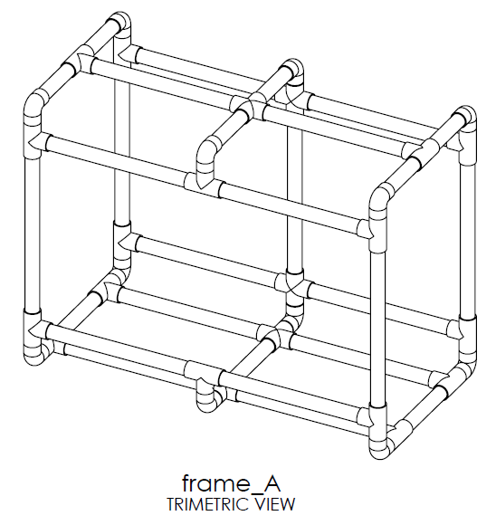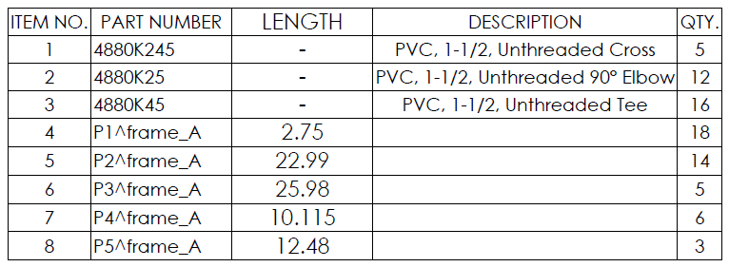

**Figure 1B.** Original PVC Frame Design

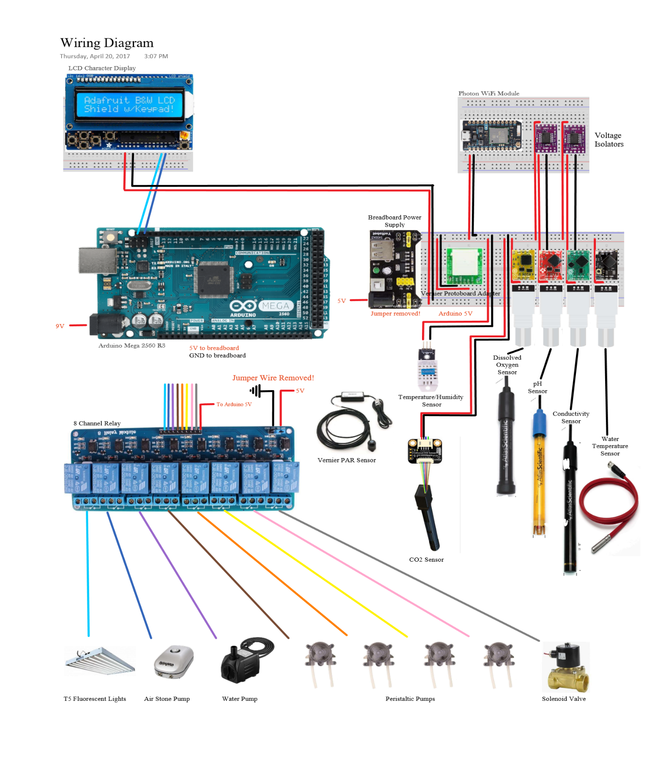

**Figure 2B.** Electrical Parts Diagram

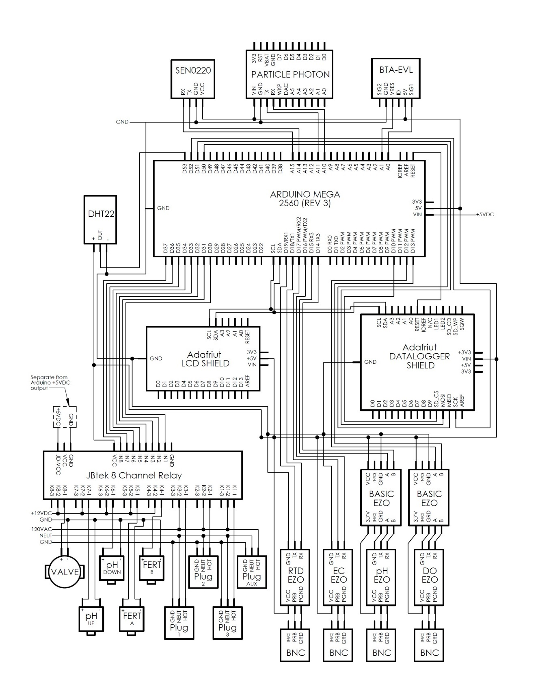

**Figure 3B**. Schematic

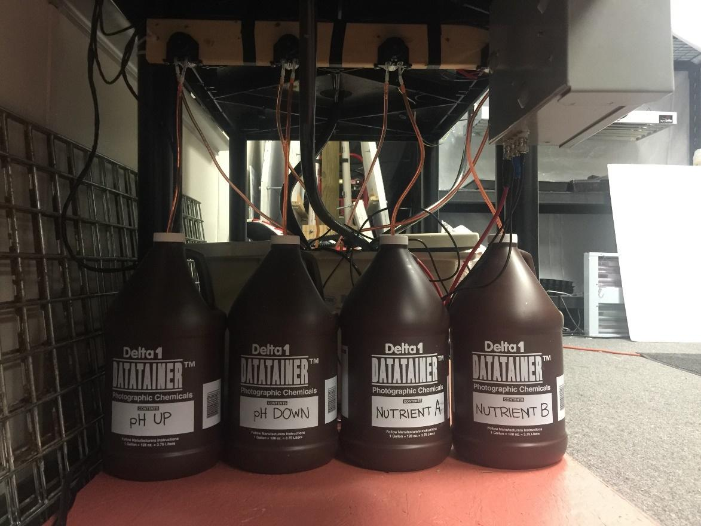

**Figure 4B.** Peristaltic Pump Setup

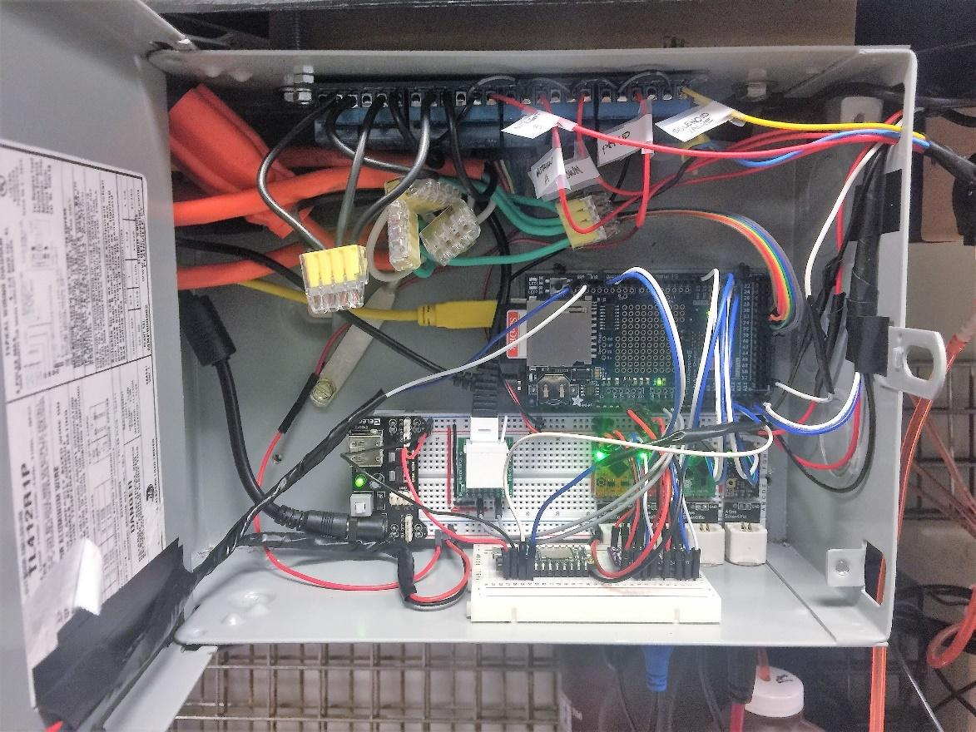

**Figure 5B.** Inside of the circuit box

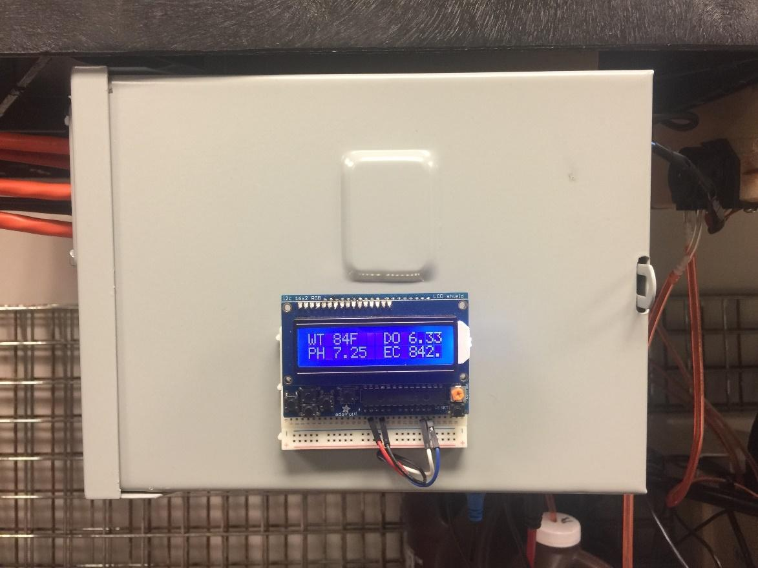

**Figure 6B.** LCD Display

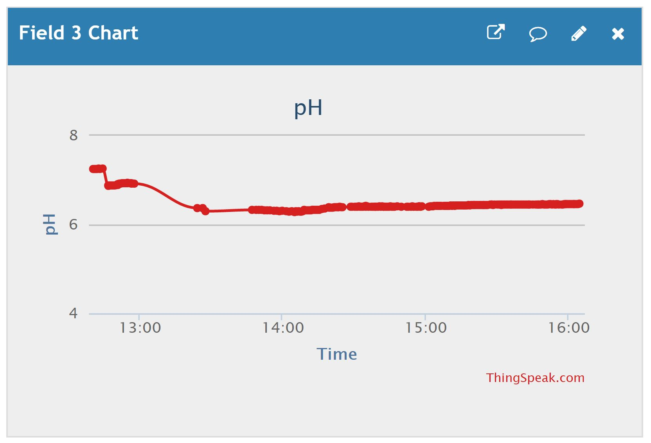

**Figure 7B.** pH Graph

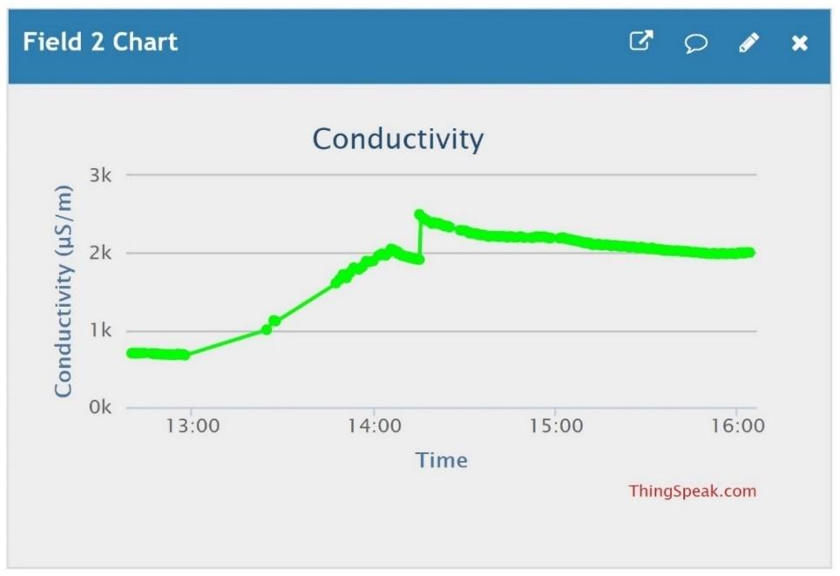

**Figure 8B.** Conductivity Graph

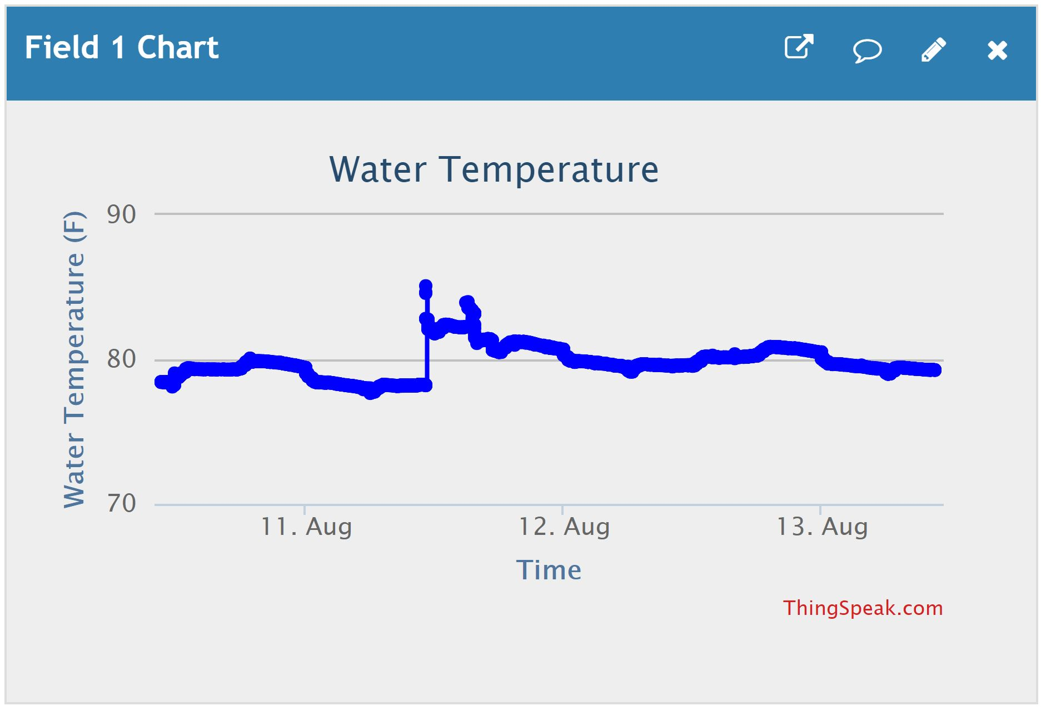

**Figure 9B.** Water Temperature Graph

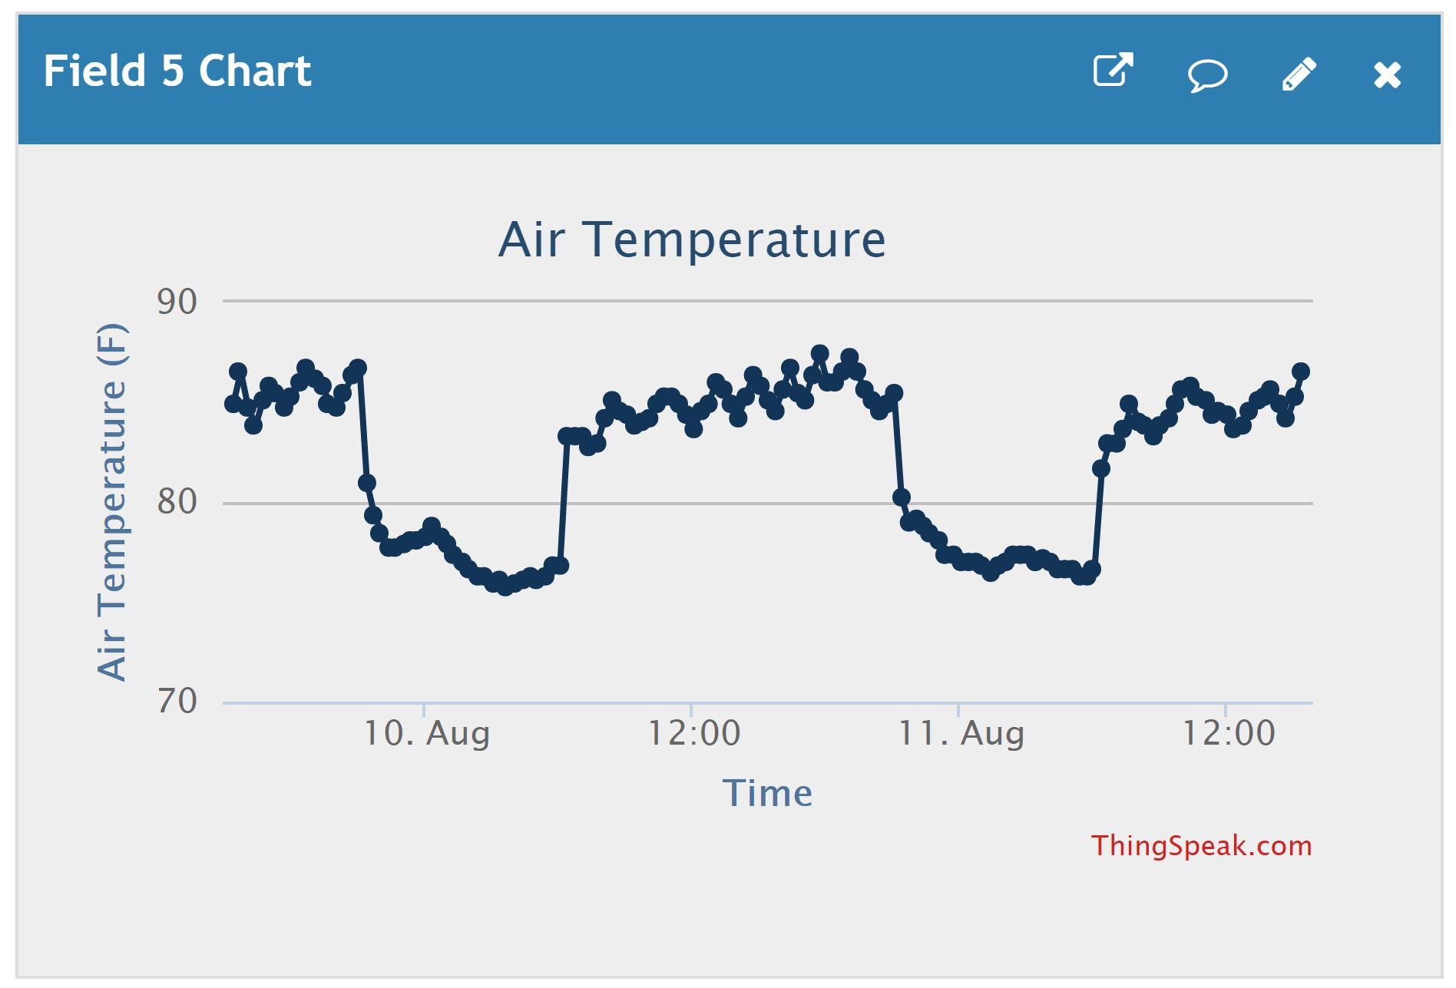

**Figure 10B.** Air Temperature Graph

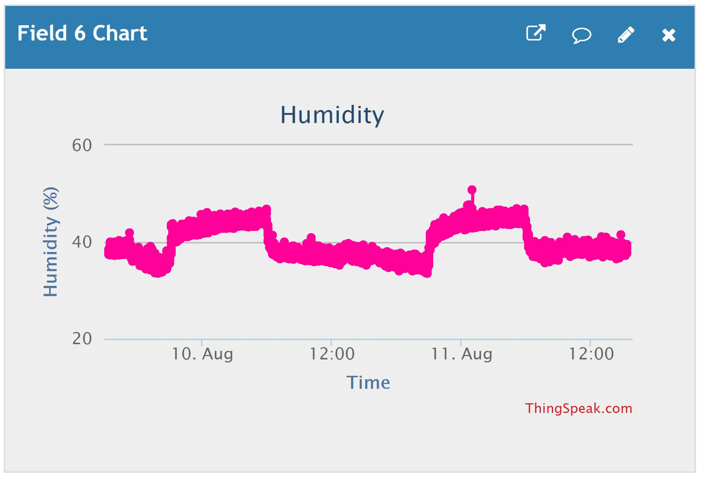

**Figure 11B.** Humidity Graph

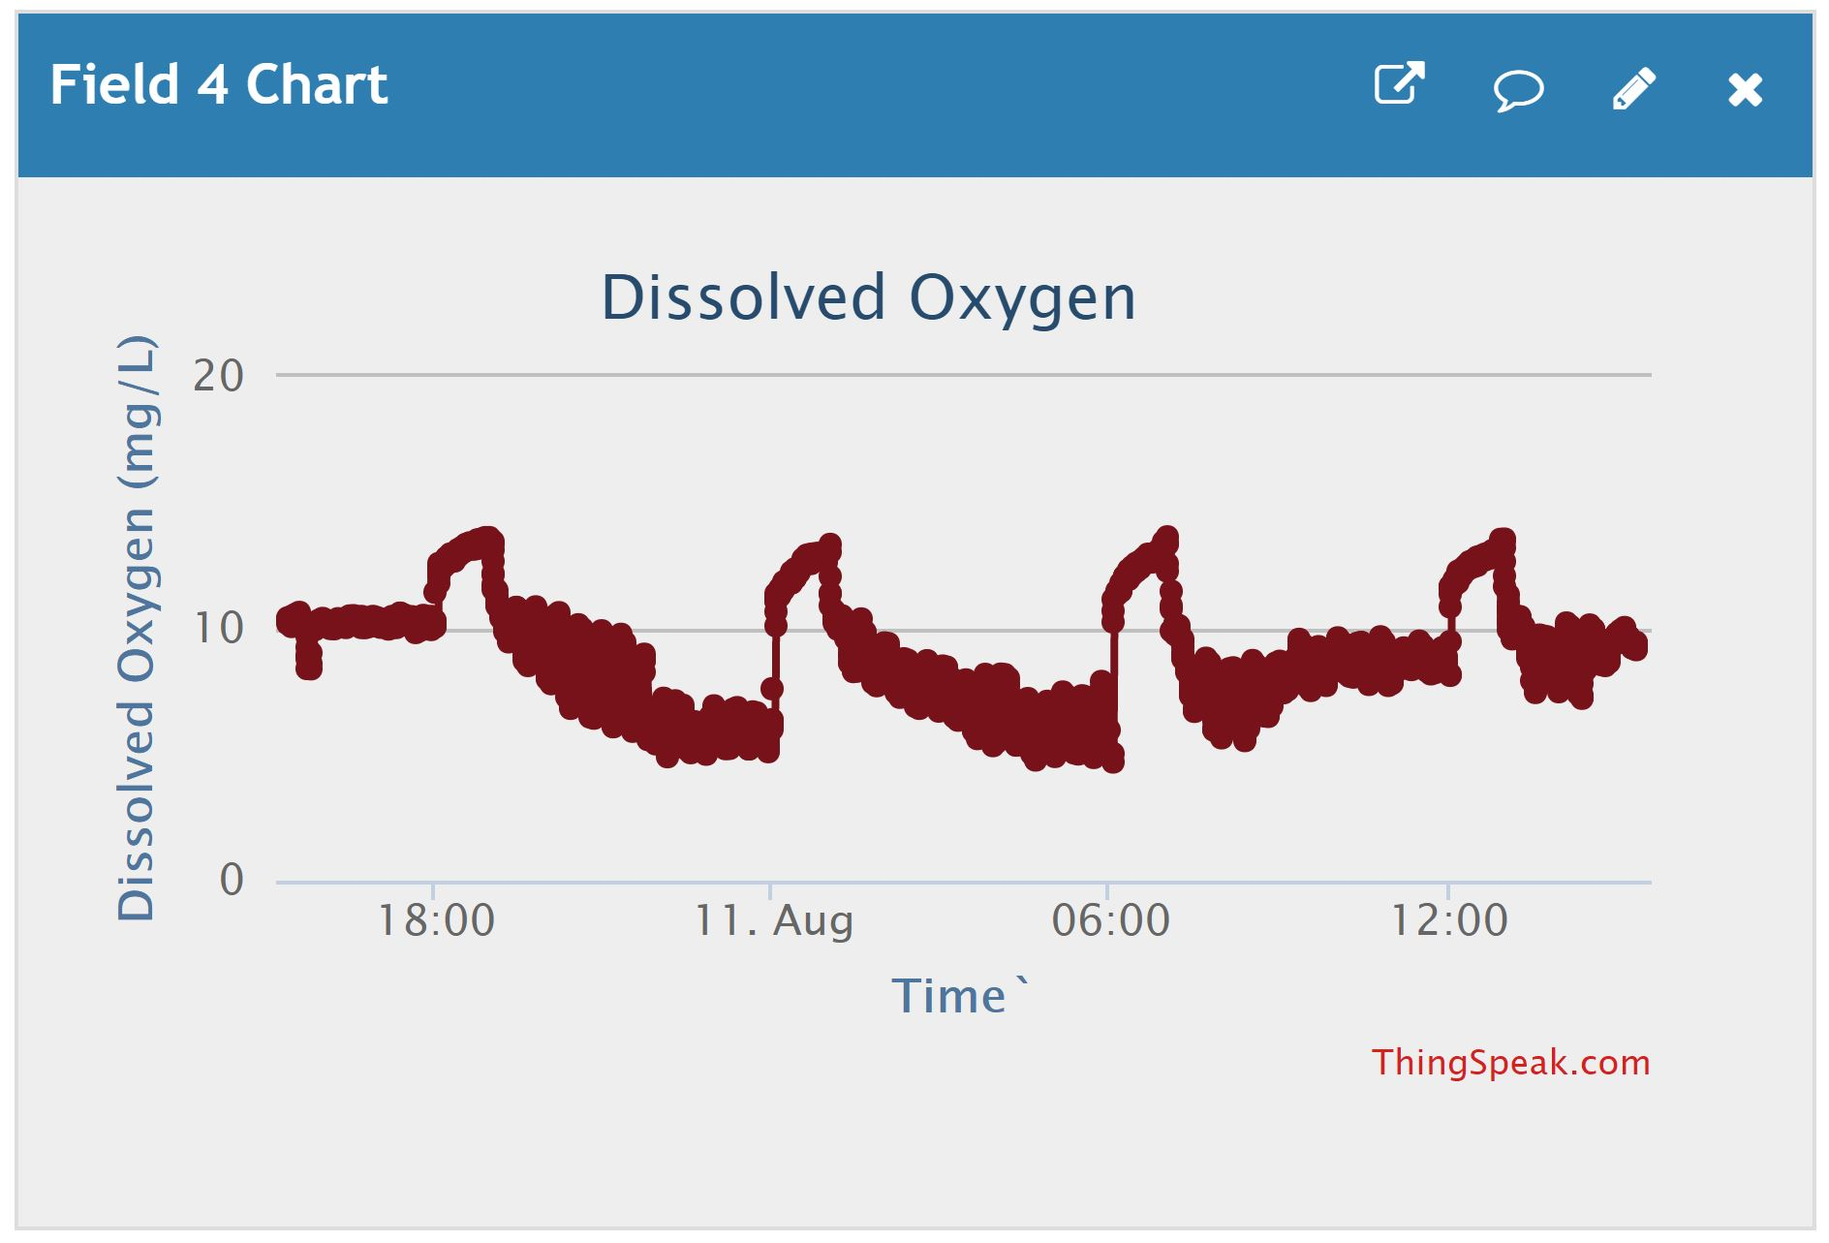

**Figure 12B.** Dissolved Oxygen Graph

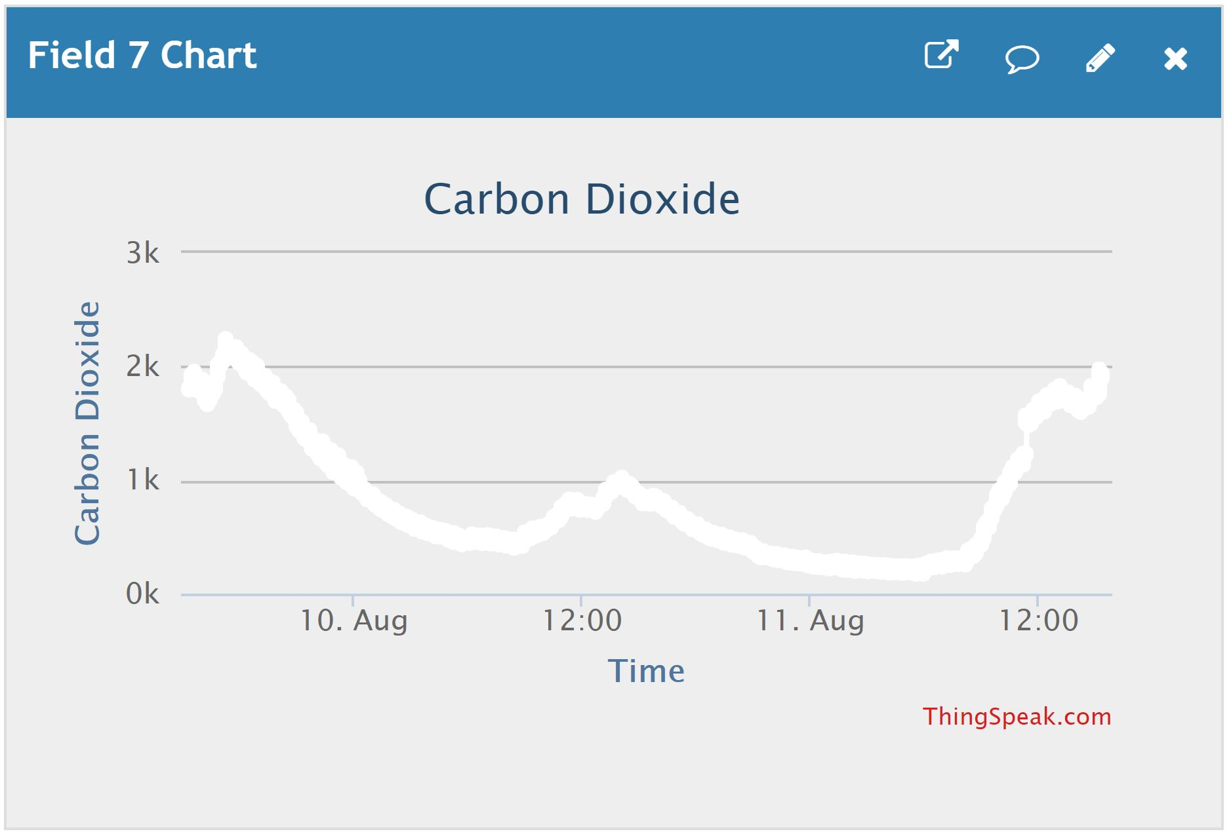

**Figure 13B.** Carbon Dioxide Graph

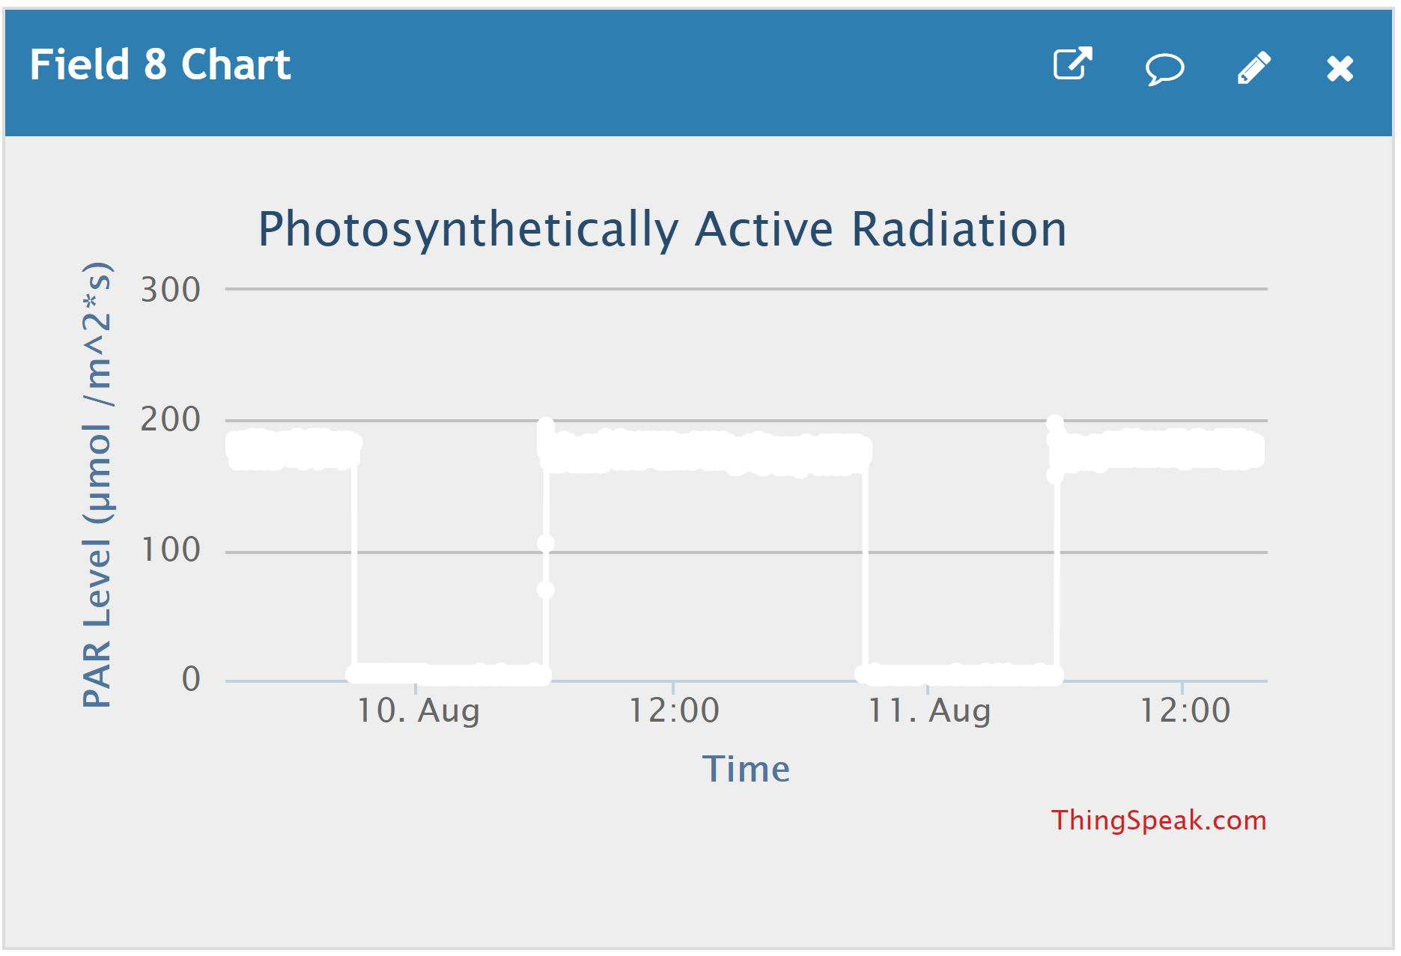

**Figure 14B.** PAR Graph

Machine generated alternative text:
Qty
Item
Manufacturer
Total Price
Product Description
1
1/2'' Black Tubing 25'
Organics
10.95
$       To add fittings to the flood table
2
1/4 in. -20 tpi x 4 in. Zinc-Plated Hex Bolt
Everbilt0.52
$         To mount electrical equipment
1
1/4 in. -20 tpi Zinc-Plated Hex Nut (25-Pack)
1.47
$         To mount electrical equipment
1
1/4 in. Galvanized Bonded Sealing Washer (4-Piece)
Everbilt0.83
$         To mount electrical equipment
1
1/4 in. Stainless Steel Split Lock Washer (6-Pack)
Everbilt1.18
$         To mount electrical equipment
12
1-1/2 in. PVC Sch. 40 90-Degree S x S Elbow
Charlotte Pipe & Foundry Co
18.12
$       To construct prototype frame
5
1-1/2 in. PVC Sch. 40 90-Degree S x S x S x S Cross
Charlotte Pipe & Foundry Co
23.00
$       To construct prototype frame
3
1-1/2-in x 20-ft 0 Sch 40 PVC DWV Pipe
Charlotte Pipe & Foundry Co
44.22
$       To construct prototype frame
1
12v Dc Electric Solenoid Valve Water  3/4" female
Hardware Factory Store
 $      20.00 To regulate the flow of extra water
1
18-Pcs Aquarium suction cups for 3/16 airline tubing holder(black)
ZLPLL8.29
$         To secure tubes entering the nutrient reservoir
1
25 ft. 16/3 Extension Cord
HDX
9.68
$         To power high voltage equipment
1
3/4'' Black Tubing 25'
Organics
24.95
$       To fill the flood table with water
1
32GB SD Card
SanDisk11.95
$       To store data as a backup
1
34 Yellow In-Sure 4-Port Connector (10-Pack)
Ideal Industries
2.58
$         To make electrical connections
4
4 mm-0.7 Zinc-Plated Metric Hex Nut (2-Piece)
Everbilt
1.48
$         To mount electrical equipment
1
5L Dutchpro Grow Hydro/Coco A/B Set - Hydroponic Nutrients
Dutchpro
68.95
$       To provide nutrients for the plants
1
9 VDC 1000mA regulated switching power adapter
Adafruit Industries6.95
$         To power the Arduino
1
Active Aqua Air Pump, 2 Outlets, 3W, 7.8 L/min
Active Aqua16.24
$       To blow air into nutrient reservoir
1
Active Aqua ASCL Air Stone Cylinder, Large
Active Aqua6.84
$         To add oxygen to nutrient reservoir
1
Active Aqua Fill/Drain Combo Kit
Organics
5.95
$         To add light to the system
1
Active Aqua Premium High Rise Flood Table for Tents, 22'' x 45''
Organics
69.95
$       To drain water from the flood table
1
Adafruit Assembled Data Logging shield for Arduino
Adafruit Industres13.95
$       To store data as a backup
1
ALITOVE 5V 10A AC to DC Power Supply Adapter
ALITOVE21.99
$       To power all 5V equipment
1
Alpha Fry AT-31604 60-40 Rosin Core Solder (4 Ounces)
Alpha Fry
8.32
$         To use with soldering iron 
1
Analog Protoboard Adapter
Vernier Software & Technologies 
10.00
$      
 
To connect Vernier PAR sensor
1
Arduino Mega Microcontroller 
SparkFun Electronics
45.95
$       To run the automation program
1
Atlas Scientific Conductivity Kit
Atlas Scientific LCC
 $    195.71 
To measure conductivity
1
Atlas Scientific Dissolved Oxygen Kit
Atlas Scientific LCC
 $    257.45 
To measure dissolved oxygen
1
Atlas Scientific pH Kit
Atlas Scientific LCC
 $    149.15 
To measure pH
1
Atlas Scientific PT-1000 Temperature Probe
Atlas Scientific LCC
 $      61.99 
To measure water temperature
2
Basic EZO™ Inline Voltage Isolator
Atlas Scientific LCC48.00
$       To electrically isolate pH and conductivity sensors
1
Blusmart 100-Watt Industrial Glue Gun
Blusmart
29.97
$       To shield connections that have been soldered 
1
Botanicare 20 Gallon Reservoir
Botanicare
42.55
$       To hold plants
1
Botanicare 20 Gallon Reservoir Lid
Botanicare
29.90
$      
 
To hold nutrient solution
1
Bread Board
Major Brand
7.95
$        
 
To make electrical connections
1
Bread Board 400 Points
OSEPP
4.99
$        
 
To make electrical connections
1
CR1220 12mm Diameter - 3V Lithium Coin Cell Battery - CR1220
Adafruit Industres
0.95
$        
 
To power the RTC
4
Delta 1 Datatainer Chemical Storage Bottle 128-oz (One Gallon) 
Delta
31.96
$      
 
To hold the nutrient solutions
1
Electronix Express - Hook up Wire Kit
Electronix Express
20.00
$      
 
To connect electrical components
1
Elegoo 120pcs Multicolored Dupont Wire
Elegoo
8.86
$        
 
To connect electrical components
1
Elegoo EL-CK-002 Electronic Fun Kit 
Elegoo
12.86
$      
 
To provide various parts for electrical installation
1
GE 8-Circuit 4-Space 125-Amp Main Lug Convertible Load Center
General Electric
30.59
$      
 
To house electrical components
4
Gikfun 12V DC Dosing Pump Peristaltic
Gikfun
50.64
$      
 
To dispense pH and nutrient solutions
1
Gravity: UART Infrared CO2 Sensor (0-50000ppm)
DFRobot93.00
$       To measure carbon dioxide levels in the air
3
Hubbell 15-Amp 125-Volt Yellow 3-Wire Connector
Hubbell19.14
$       To power high voltage equipment
1
JBtek 8 Channel DC 5V Relay Module for Arduino 
Jbtek
8.98
$         To power high voltage equipment via Arduino
16
LASCO 1-1/2-in Dia PVC Sch 40 Tee
LASCO Fittings, Inc.
28.48
$       To construct prototype frame
1
LCD Shield Kit w/ 16x2 Character Display 
Adafruit Industries19.95
$       To display level readings
1
M4 Zinc-Plated Split Lock Washers (4-Piece)
0.43
$         To mount electrical equipment
2
M4-.7 x 10 mm Plain Steel Metric Socket Cap Screw (2-Piece)
Everbilt
1.04
$         To mount electrical equipment
1
OMEGAFLEX® Polypropylene Tubing - 100ft
OMEGA20.50
$       To dispense pH and nutrient solutions
1
Particle Photon
Particle19.00
$       To connect to the internet
1
pH UP and DOWN Solution
Atlas Scientific LCC23.00
$       To regulate pH level of the water
1
Reliance Products Jumbo-Tainer 7 Gallon Jerry Can Style Rigid Water Container
Reliance Products23.28
$       To store extra water
1
Sigma Electric 10-Pack 3/8-in NM/SE Connector
Sigma Electric Manufacturing Corporation2.38
$         To make electrical connections
1
Sleek Airline Tubing in Black
Lee's Aquarium5.24
$         To connect air pump to air stone
2
SMAKN® DHT22 / AM2302 Digital Temperature and Humidity measure sensor
SMAKN19.98
$       To measure air temperature and humidity
1
Stanley 10 in. Dual Temp Glue Sticks (12 Pack)
Surebonder6.87
$         To use with glue gun 
1
T5 Agrobrite 4'/6-Tube System w/bulbs
Organics
202.95
$     To provide light for the system
1
USB Cable standard A-B 3’/1m
Adafruit Industries3.95
$         To connect Arduino to computer
1
Utilitech 25-Pack Plastic Wing Wire Connectors
Utilitech
3.58
$         To make electrical connections
1
Vernier PAR Sensor
Vernier Software & Technologies 
199.00
$     To measure PAR levels of light source
1
Weller WLC100 40-Watt Soldering Station
Weller
35.11
$       To solder wired connections 
1
WiFi Antenna
Particle
10.00
$       To strengthen WiFi signal
1
YGDZ Top Quality 2 Pack Desoldering Wick
YGDZ7.99
$         To remove excess solder or to desolder connections 
TOTAL EXPENSES: 
2,191.68
$ 
 
**Appendix C – Budget**

|  |  |  |
| --- | --- | --- |
| **Suggested Equipment** | **Price** | **Purpose** |
| [Water chiller](https://heavygardens.com/active-aqua-chiller-1-10-hp.html?fee=2&fep=7805&utm_source=google_shopping&utm_medium=feed&utm_campaign=HG_googleshop_CSV&gclid=Cj0KCQjwiLDMBRDFARIsACNmiX8olY_sm1vc_WWMBlstCoh_OB2s9q4GkLVa9tkCOHdRrp8DfkTC0G8aAo19EALw_wcB) | $296.36 | To control water temperature |
| [Fan](https://www.ebay.com/p/Hydrofarm-Active-Air-ACF16-Wall-Mount-Fan-16-Inch/572361945?iid=112500029181) | $37.50 | To assist in controlling air temperature |
| [Dehumidifier/humidifier](https://www.amazon.com/Frigidaire-FFAD7033R1-Dehumidifier-Effortless-Humidity/dp/B00UWP07LK/ref=pd_sbs_60_1?_encoding=UTF8&pd_rd_i=B00UWP07LK&pd_rd_r=2ST8S4YP08PG9E9VNX15&pd_rd_w=hKgfr&pd_rd_wg=fL0jc&psc=1&refRID=2ST8S4YP08PG9E9VNX15) | $236.42 | To control humidity |
| [CO2 Emitter](https://www.amazon.com/Hydroponics-Co2-Regulator-Solenoid-Accurate/dp/B016NGH4M6/ref=pd_bxgy_328_2?_encoding=UTF8&pd_rd_i=B016NGH4M6&pd_rd_r=D4T3M8BFAFF842MTDB0P&pd_rd_w=fIcqN&pd_rd_wg=763bY&psc=1&refRID=D4T3M8BFAFF842MTDB0P) | $49.99 | To control carbon dioxide levels |
| [CO2 Tank](https://www.amazon.com/Aluminum-Cylinder-Handle-CGA320-Valve/dp/B0088P10OO/ref=pd_bxgy_86_3?_encoding=UTF8&pd_rd_i=B0088P10OO&pd_rd_r=P32JHEVSSKCKDMJXD4ZK&pd_rd_w=J9SSg&pd_rd_wg=2wH6T&psc=1&refRID=P32JHEVSSKCKDMJXD4ZK) | 129.95 | To control carbon dioxide levels |
| Total cost | $750.22 |  |